**Open Enrollment Instructions**

To enroll in benefits, go to: [www.plansource.com/login](http://www.plansource.com/login) .

**Login Page**

Enter your username and password.

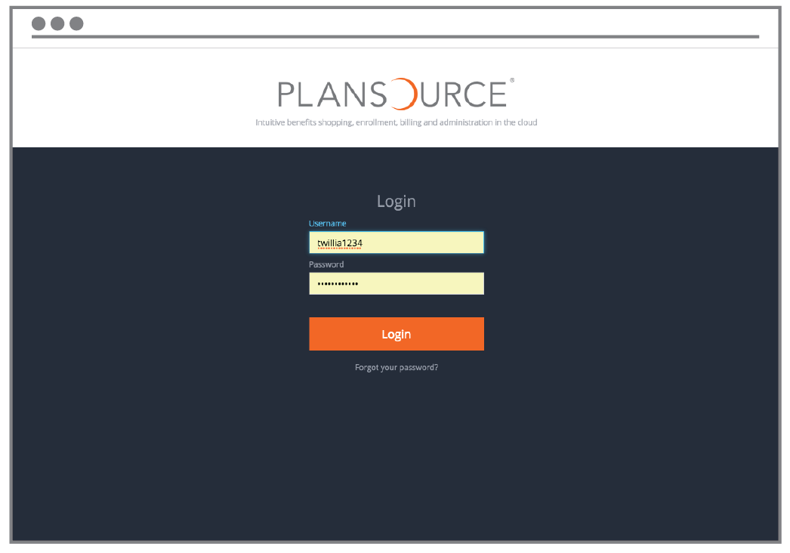

**Username:** Your username is the first initial of your first name, up to the first six letters of your last name, and the last four digits of your SSN.

For example, if your name is Taylor Williams, and the last four digits of your SSN are 1234, your username would be twillia1234.

**Password:** Your initial password is your birthdate in the YYYYMMDD format.

So, if your birthdate is June 4, 1979, your password would be 19790604. The first time you log in, you will be prompted to change your password.

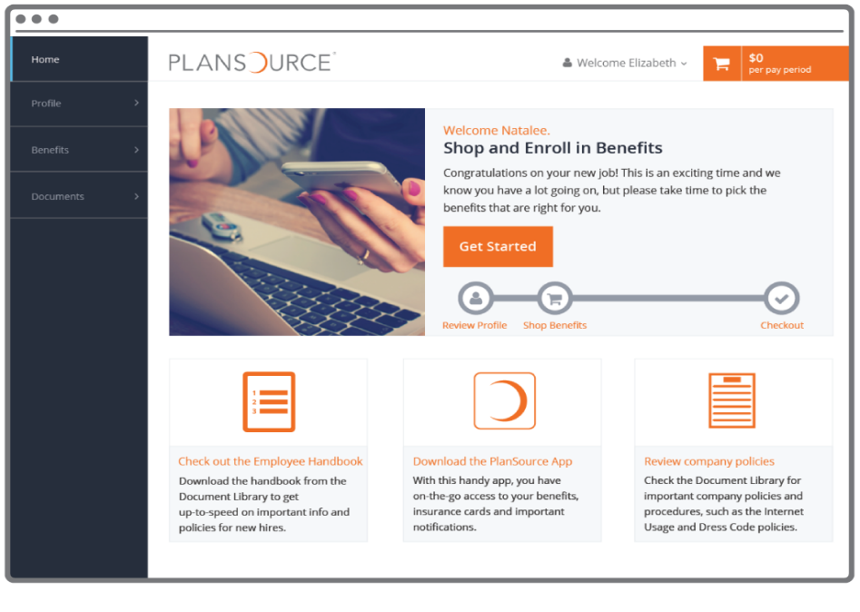

**Homepage**

On the Homepage, click   
“Get Started” to begin.

**Enroll in Benefits**

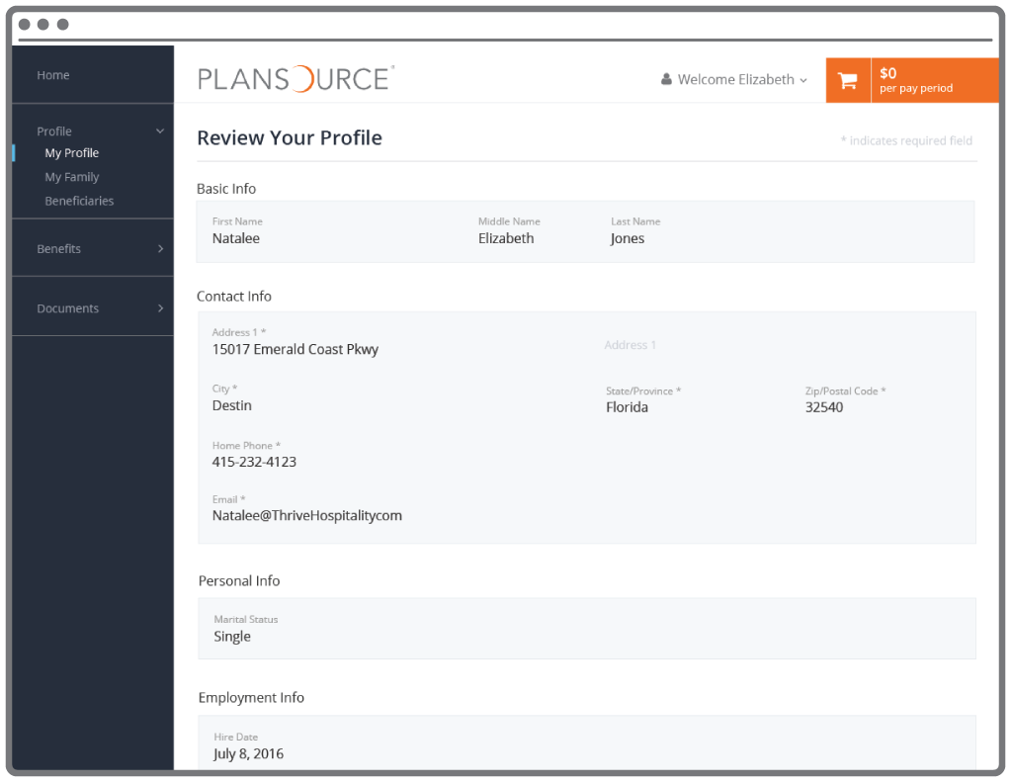

**Profile**

First, you’ll be asked to review and update your profile and ensure that all information listed about yourself and your family members is correct.

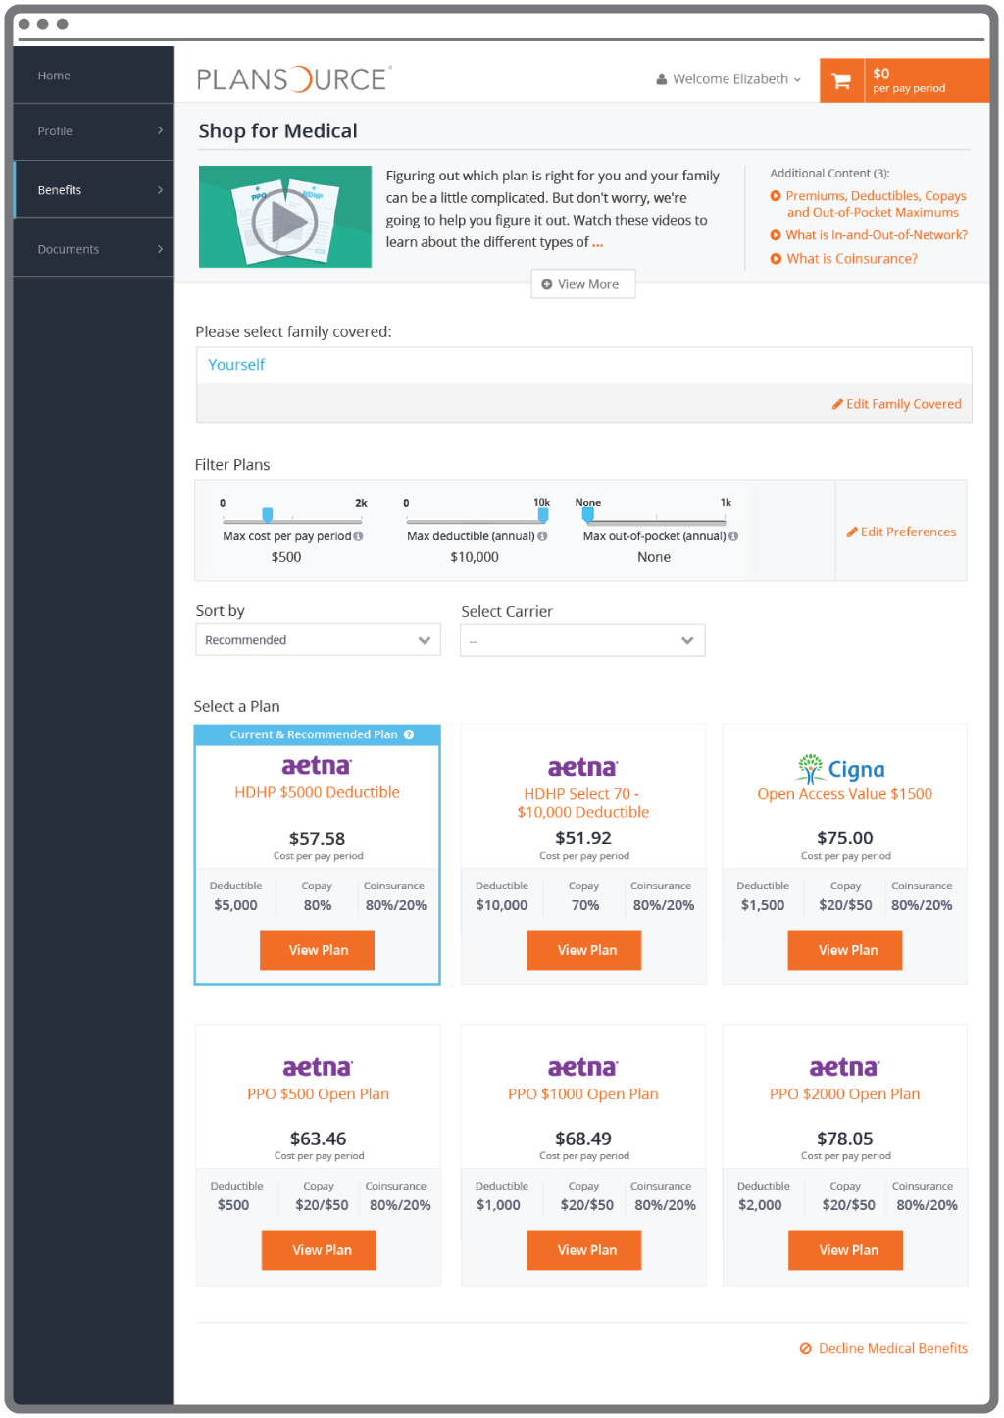

**Shop for Benefits**

You can then begin shopping for benefits!

Educational material about the specific plan type is available at the top of the page.

**Filter**

If your company offers three or more plans, you’ll be able to filter available plans based on a variety of criteria.

**Plan Overview**

Plan choices are displayed on “cards,” which provide a brief summary of what is included in the plan. Click a card to get more detail.

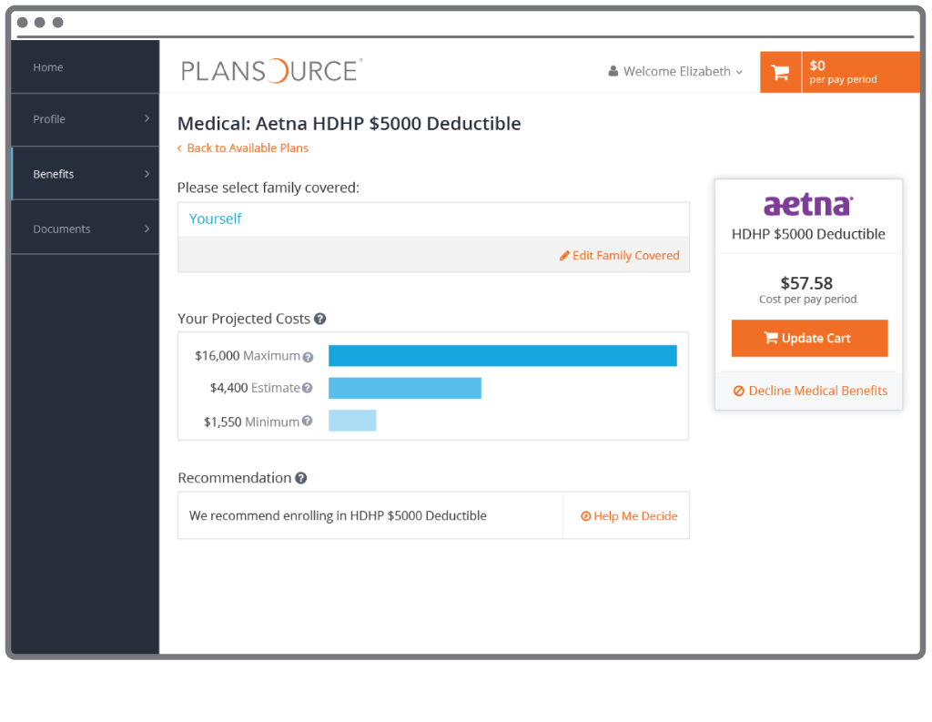

**Plan Details**

The plan detail page will give you information about each plan, including deductible, cost per pay period and projected costs.

**Select Plan**

To select a plan, indicate which family members are covered by clicking “edit family covered” and select the card for each family member you’d like to be on the plan.

Click “Update Cart” to choose the plan.

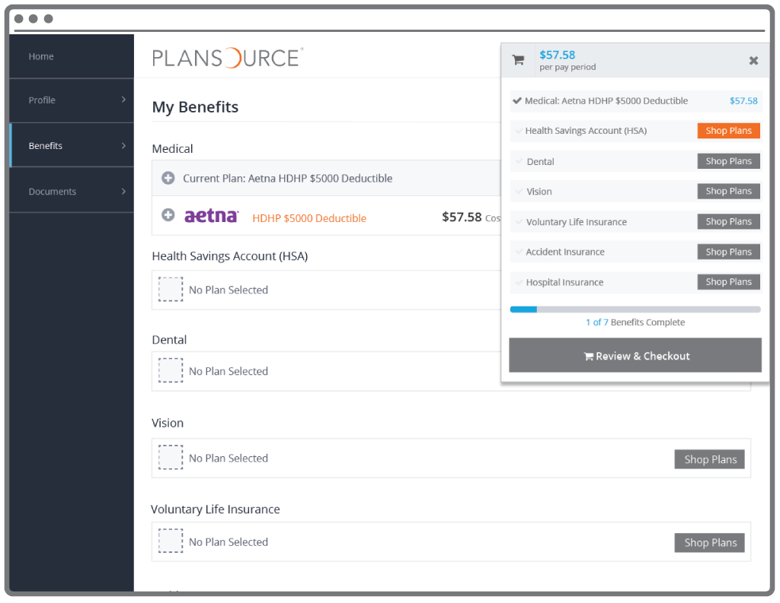

**Shopping Cart**

The shopping cart displays a running total of your combined benefits costs and shows your progress. You will need to select or decline a plan in each benefit type before you can check out.

**Checkout**

To finalize your choices, click “Review and Checkout.” You must complete the checkout process in order to be enrolled in benefits.